OLIVE DRAB

JOURNAL

OF THE

MILITARY VEHICLE PRESERVATION SOCIETY

OF SOUTH AUSTRALIA
AND
THE NATIONAL MILITARY VEHICLE MUSEUM
Telephone (08) 8285 3011
ABN 36 547 733 430
http://www.military-vehicle-museum.org.au

Mail to: PO Box 174, Salisbury, SA 5108
Or visit the Museum, 10 Sturton Rd., Edinburgh Parks, SA 5111

JULY 2013 Vol. 13 Issue 7

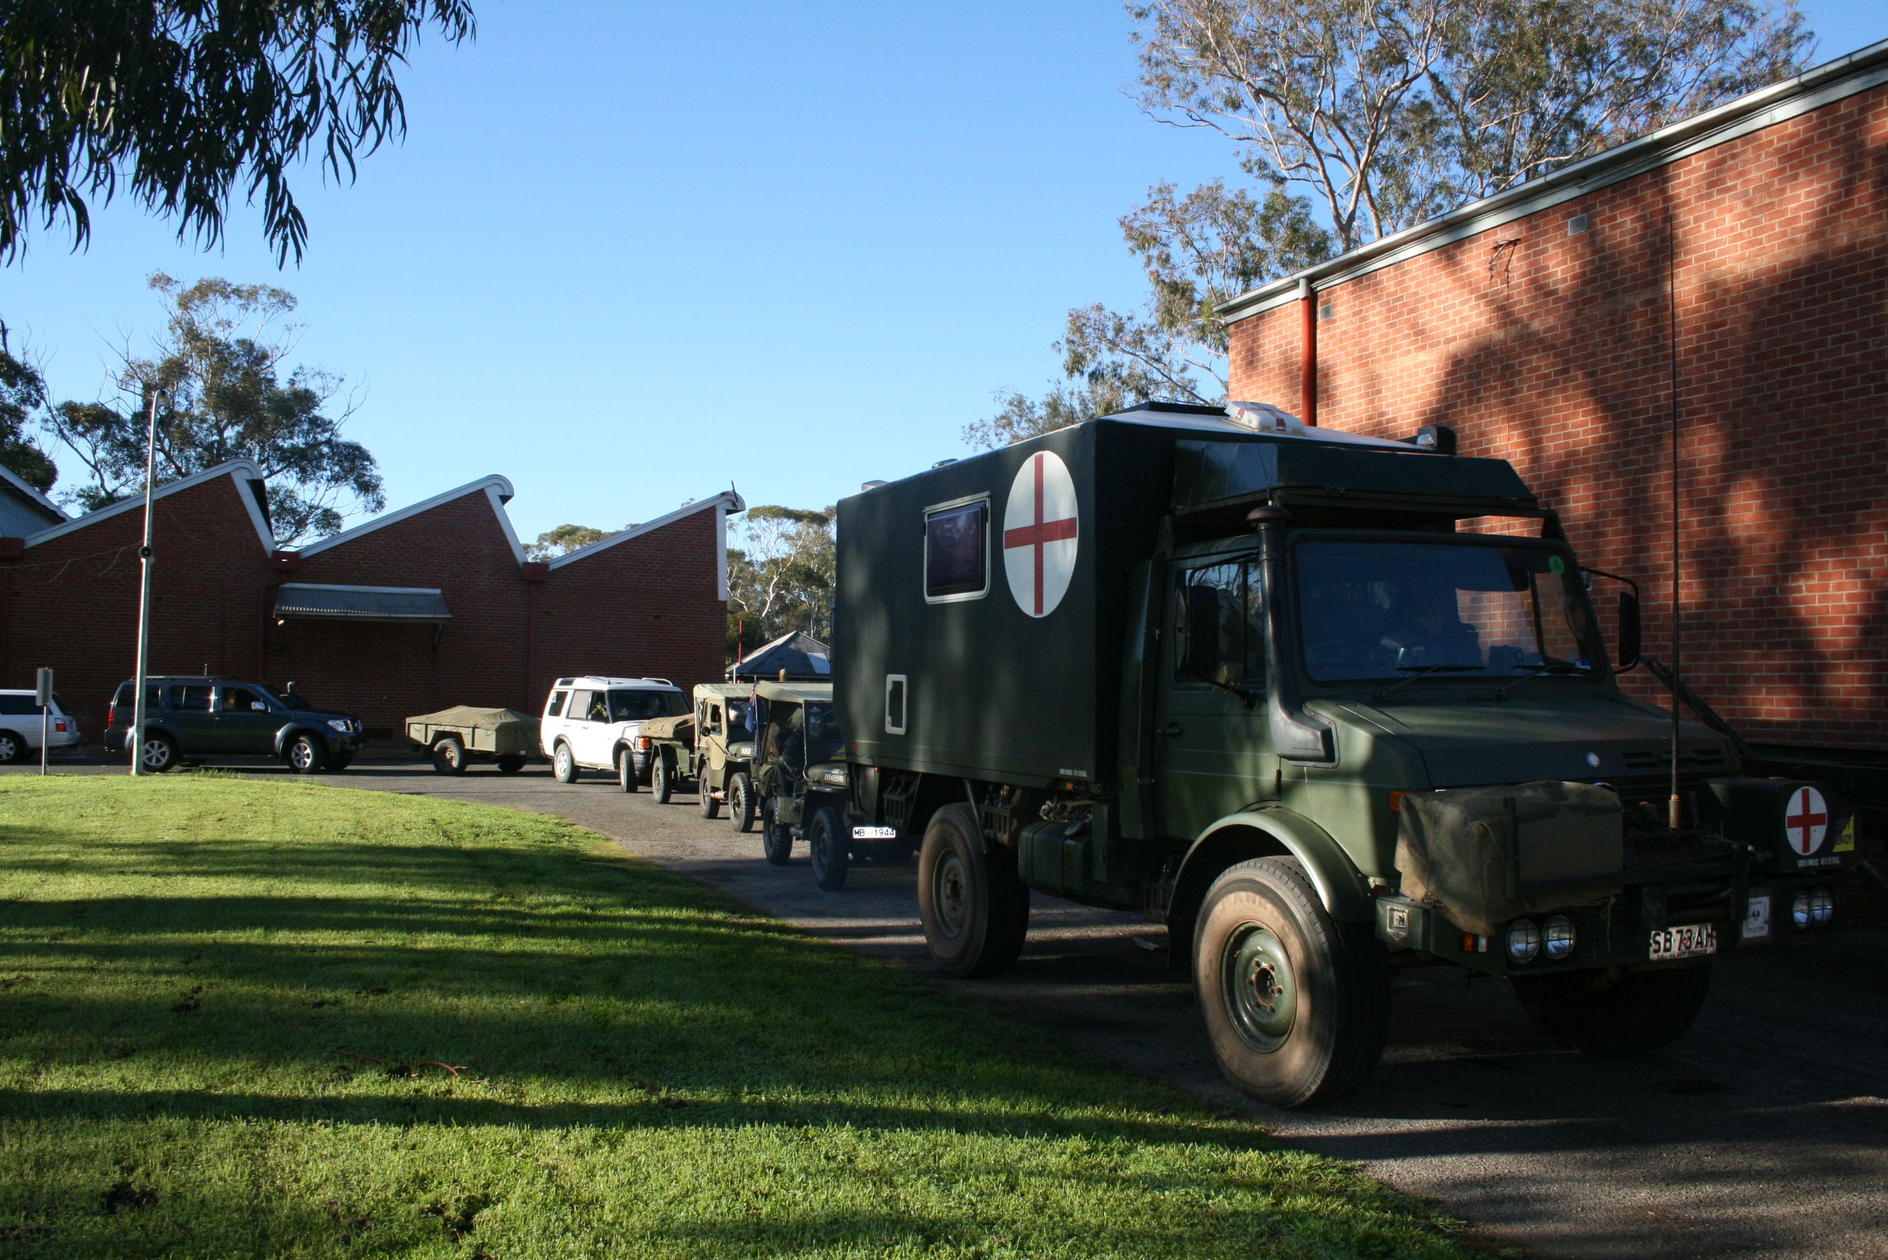

The MVPSSA support component for the RACT Convoy departing the Museum.

